sudo apt-get update && sudo apt upgrade -y

sudo apt install snapd

sudo snap install microk8s --classic

# microk8s.kubectl

sudo usermod -a -G microk8s (username)

sudo chown -f -R (username) ~/.kube

snap alias microk8s.kubectl kubectl

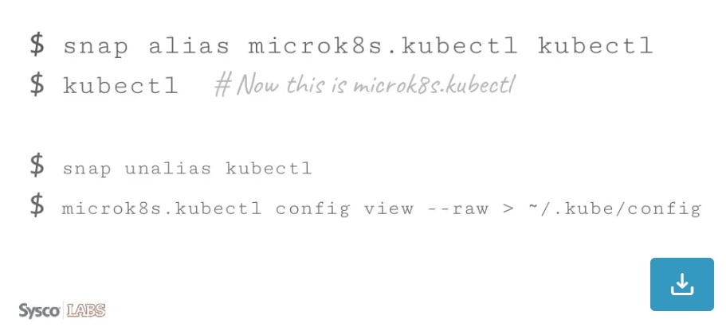

Newgrp microk8s

echo "alias kubectl='microk8s kubectl'" >> ~/.bashrc

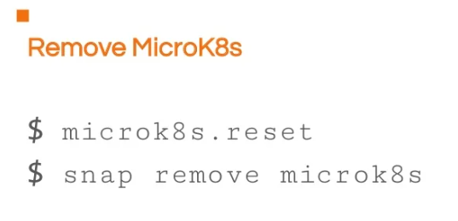

microk8s.reset

snap remove microk8s

kubectl apply -f https://k8s.io/examples/service/load-balancer-example.yaml

kubectl get deployments hello-world

kubectl get replicasets

kubectl expose deployment hello-world --type=LoadBalancer --name=my-service

kubectl get services my-service

kubectl describe services my-service

kubectl get pods --output=wide